|  |
| --- |
| ServicePlace |
| ServicePlace Elder Care System |
|  |
|  |
| **Nirav Shah**  **Mitchell Langston**  **Rachel Dedinsky**  **Benry Dong**  **Nicholas Mel** |
| **December 2017** |

|  |
| --- |
| Contained in this document are the Application Architecture and structure for the Service Elder Care System including notifications, service tracking and the ability to add external services. |

**Table Contents**

Overall Application Architecture 2

Core Application Components 2

1. Safety and Emergency 2

2. Food and Hygiene 2

3. Health and Medical 3

4. Family and Community 3

Support Application Components 3

1. User Account Management 3

2. Access Control 3

Mobile Application Components 3

1. Notifications 3

Configuration services 3

1. Programmable Skills 3

2. Development Interface 3

Interfaces 3

1. Safety and Emergency 3

2. Food and Hygiene 3

3. Health and Medical 3

4. Family and Community 4

Application structure 5

Incoming Request Processor 5

Account and Mobile Processor 5

Offering Module Processors 5

Service Communicator 5

Application Assumptions: 6

# Overall Application Architecture

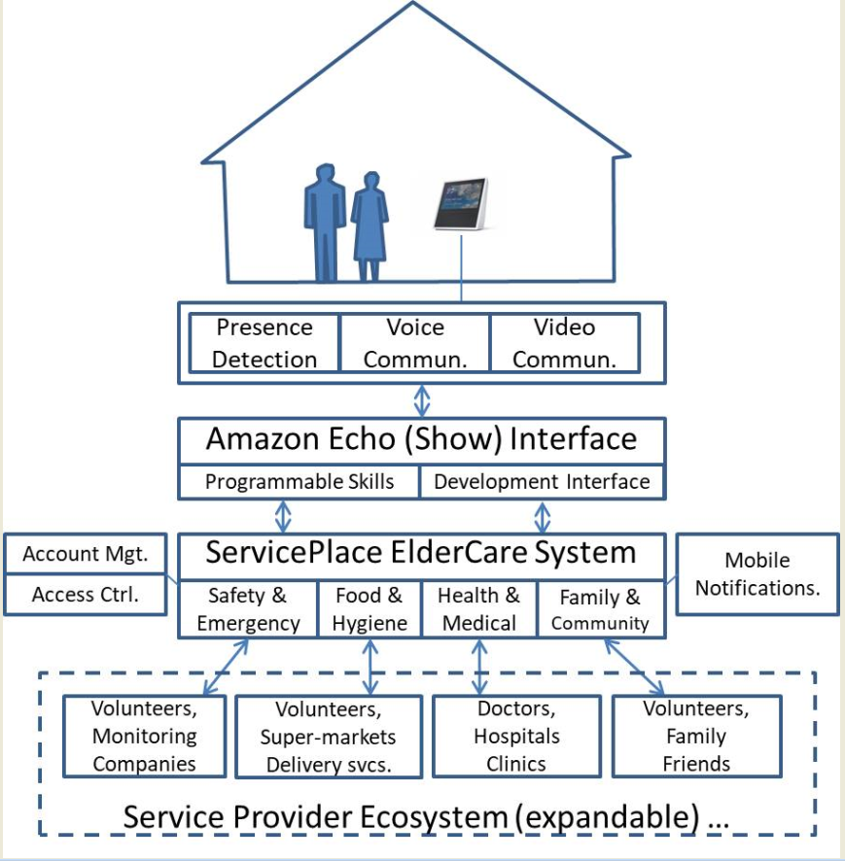

The above application modules are explained below with proper details.

## Core Application Components

### Safety and Emergency

* Emergency Notifications
* Device Alarms/Locking
* Device Location tracking
* Support for managed emergency services

### Food and Hygiene

* Add and remove items from grocery list
* Process and order items
* Process payment through Amazon
* Payment and shipping confirmation
* Delivery service order tracking
* Notifications on delivery status of order

### Health and Medical

* IoT sensor integration
  + First iteration: use a raspberry pi to do the computing and send the medical sensor measurements to the server to return to the Amazon Echo Show on request
* Health Insurance Portability and Accounting Act (HIPAA) compliance
  + Ensuring the system is future-proof in the initial creation of the system by having the system comply to the all HIPAA regulations and laws

### Family and Community

* Process and authenticate temporary drop in feature
* Process calls to Amazon
* Return calls to Alexa

## Support Application Components

### User Account Management

* ‘Login with Amazon’ support
* Account creation
* Applicable Services/Subscriptions tied to account
* Used for retrieval of applicable data

### Access Control

* Household Accounts (multiple authorized users)
* Limit application

### Account linking with Amazon Services

* Access Tokens, refresh intervals
* Authorization webpage
* OAuth

## Mobile Application Components

### Notifications

### Service Monitoring - view pending requests, create new requests

### Access Service Requests

### Access Account Management

## Configuration services

### Programmable Skills

* Notification Triggers
* Setup recurring services/requests

### Development Interface

* API for external service integration

## Interfaces

### Safety and Emergency

#### Volunteers

#### Monitoring Companies

#### Family Member involvement

#### External Security Devices

### Food and Hygiene

#### Volunteers

#### Supermarkets Delivery Service

### Health and Medical

#### Doctors

#### Hospital/Clinics

#### Laboratory Services

### Family and Community

#### Family

#### Friends

# Application structure

The application need following main components:

## Incoming Request Processor

This module is responsible to parse incoming requests. If it is coming from AWS, Mobile or any other communication media this processor will recognize it and point it to the correct direction.

## Account and Mobile Processor

This module will handle the communication with account and mobile service requests.

## Offering Module Processors

These are the individual modules which are capable of offering services to the application. Individual service request processing is part of this module.

## Service Communicator

This will take care of all inbound and outbound communications from application to the service provider.

## Alexa Request Processor

Verifies requests from Amazon services- verifying Certificates, timestamps - directed from the Incoming Request Processor, requests and receives information from the Offering Module Processors.

# Application Assumptions:

1. The application will not store or manage any sensitive information to the user.
2. The application will not come in the process where it will have to be PCI compliant or HIPPA compliant.
3. The application will not be certified against any of the 3rd party certification, except self-certification.
4. The application will not provide the user services before verifying said user’s credentials.